



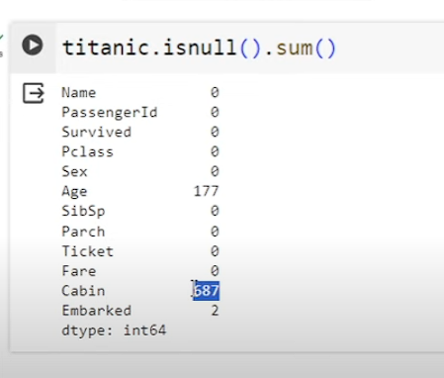

Handling null values can be done in 2 ways a)Imputation(by filling)

b)Dropping

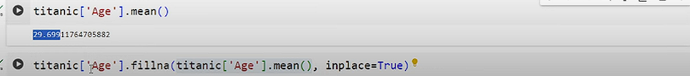

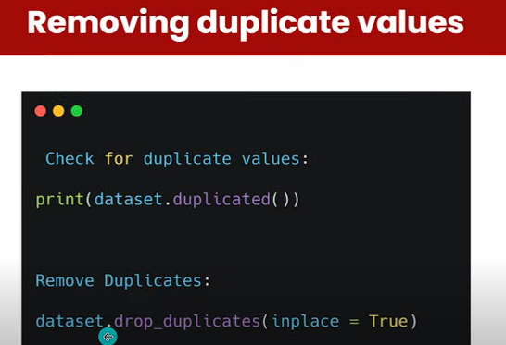

Numpy(Numerical Python)

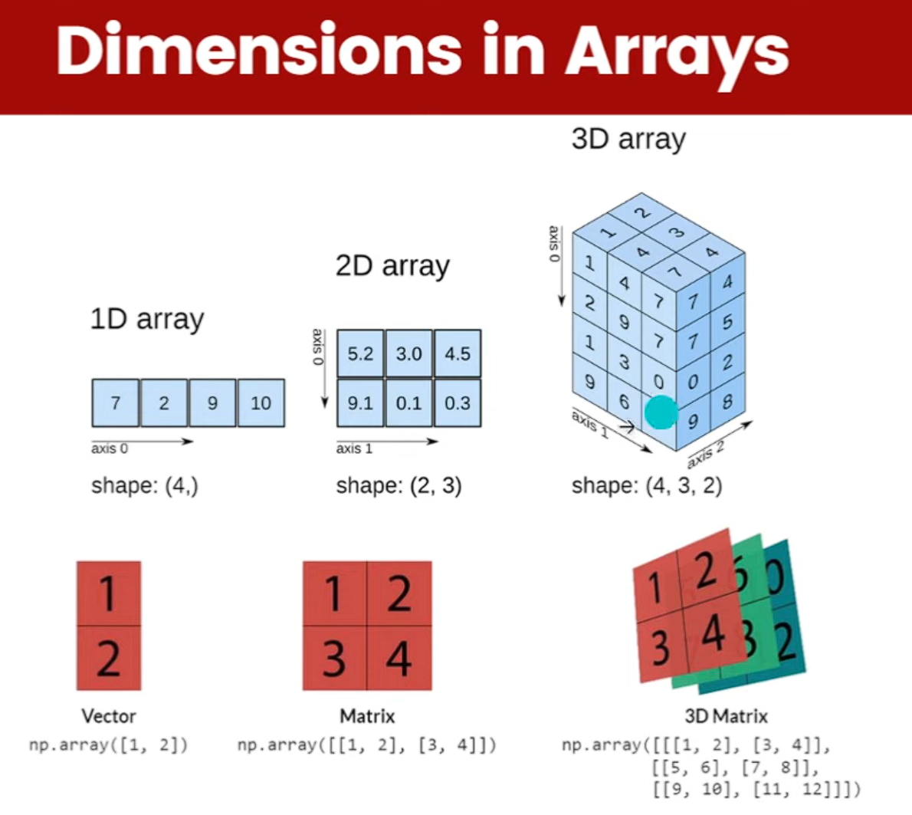

X = np.array([1,2,3,4,5])

Y = x.copy()

It is deep copy means if we make any changes in y then that will not be reflected in x

Y = x.view() //it creates a new variable to look at same memory location

So, if you make any changes to x, then that will be reflected in y

(3,2,3) there are 3 two dimension 2 one dimension and inside that 3 elements

x.reshape(-1) #reshape any dimension to 1d

for iterating

for I in 2d:

for j in i:

for k in j:

for joining 2 array = np.cancatenate(x,y) #if we pass an additional argument axis = 1 it will combine them as 1d

for searching .. for sorting np.sort(x)

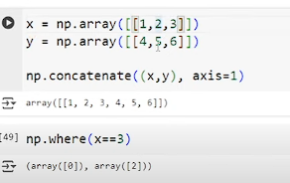

Np.zeroes((1080,1080))

Np.ones((4,4))

Np.full((4,4),8) will create a 4\*4 and fill with 8

Np.arange(3,15,3) #like normal range function in python

